
COURSE NAME
Information Security Lab
Assignment No: 08
Submitted To: Ma’am Sadaf Ayub
Submitted By: Spogmai Jan
2430-0081
Submission Date: 11/16/2025
DEPARTMENT OF Computer Science
SIR SYED CASE INSTITUTE OF TECHNOLOGY, ISLAMABAD

Task No 01:
Encryption:
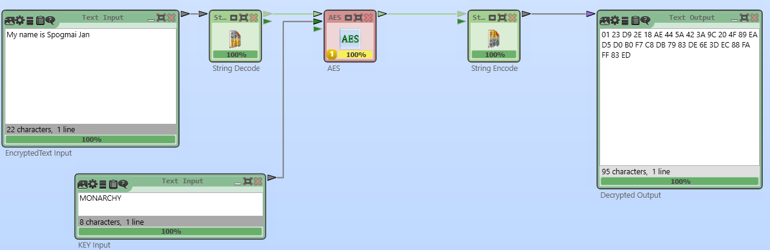

Decryption:
